实验7 处理器调度

实验目的
- 理解进程调度的过程。
- 掌握各种进程调度算法的实现方法
- 通过实验比较各种进程调度算法的优劣。

实验内容
随机给出一个进程调度实例，如：
进程 到达时间 服务时间
A 0 3
B 2 6
C 4 4
D 6 5
E 8 2
模拟进程调度，给出按照算法先来先服务FCFS、轮转RR（q=1）、最短进程优先SPN、最短剩余时间SRT、最高响应比优先HRRN进行调度各进程的完成时间、周转时间、响应比的值。

实验环境
ubuntu-22.04.5

实验中遇到的主要问题及其解决方式
无

源代码
#include<stdio.h>
#include<stdlib.h>
#include<string.h>
#include<stdbool.h>
#define MAX_PROCESS 10
typedef struct
{
char name;
int arrival_time;
int service_time;
int start_time;
int finish_time;
int turnaround_time;
float weighted_turnaround;
float response_ratio;
int remaining_time;
int waiting_time;
}Process;
Process processes[MAX_PROCESS];
int n=5;
void initialize_processes()
{
processes[0].name='A';
processes[0].arrival_time=0;
processes[0].service_time=3;

processes[1].name='B';
processes[1].arrival_time=2;
processes[1].service_time=6;

processes[2].name='C';
processes[2].arrival_time=4;
processes[2].service_time=4;

processes[3].name='D';
processes[3].arrival_time=6;
processes[3].service_time=5;

processes[4].name='E';
processes[4].arrival_time=8;
processes[4].service_time=2;
}
void reset_processes()
{
for(int i=0;i<n;i++)
{
processes[i].start_time=-1;
processes[i].finish_time=-1;
processes[i].turnaround_time=0;
processes[i].weighted_turnaround=0;
processes[i].response_ratio=0;
processes[i].remaining_time=processes[i].service_time;
processes[i].waiting_time=0;
}
}
void print_result(char* algorithm_name)
{
printf("\n%s's result:",algorithm_name);
printf("\nprocess\tarrival time\tservice time\tstart time\tfinish time\tturnaround time\tweighted turnaround time");
if(strcmp(algorithm_name,"HRRN")==0)
printf("\tresponse ratio");
printf("\n");
float avg_turnaround=0;
float avg_weighted_turnaround=0;

for(int i=0;i<n;i++)
{
printf("%c\t%d\t\t%d\t\t",processes[i].name,processes[i].arrival_time,processes[i].service_time);
if(processes[i].start_time!=-1)
{
printf("%d\t\t%d\t\t%d\t\t%.2f",processes[i].start_time,processes[i].finish_time,processes[i].turnaround_time,processes[i].weighted_turnaround);
}
else
{
printf("-\t\t-\t\t-\t\t-");
}
if(strcmp(algorithm_name,"HRRN")==0)
{
printf("\t\t%.2f",processes[i].response_ratio);
}
printf("\n");
if(processes[i].finish_time!=-1)
{
avg_turnaround+=processes[i].turnaround_time;
avg_weighted_turnaround+=processes[i].weighted_turnaround;
}
}
printf("average turnaround time: %.2f\n",avg_turnaround/n);
printf("avergge weighted turnaround time: %.2f\n",avg_weighted_turnaround/n);
}
void fcfs_scheduling()
{
reset_processes();
int current_time=0;
int completed=0;
while(completed<n)
{
int next_process=-1;
int min_arrival=1000;
for(int i=0;i<n;i++)
{
if(processes[i].arrival_time<=current_time&&processes[i].start_time==-1&&processes[i].arrival_time<min_arrival)
{
min_arrival=processes[i].arrival_time;
next_process=i;
}
}
if(next_process!=-1)
{
processes[next_process].start_time=current_time;
processes[next_process].finish_time=current_time+processes[next_process].service_time;
processes[next_process].turnaround_time=processes[next_process].finish_time-processes[next_process].arrival_time;
processes[next_process].weighted_turnaround=(float)processes[next_process].turnaround_time/processes[next_process].service_time;
current_time=processes[next_process].finish_time;
completed++;
}
else
{
current_time++;
}
}
print_result("FCFS");
}
void rr_scheduling()
{
reset_processes();
int current_time=0;
int completed=0;
int queue[MAX_PROCESS*10];
int front=0,rear=0;
bool in_queue[MAX_PROCESS]={false};
for(int i=0;i<n;i++)
{
if(processes[i].arrival_time<=current_time&&processes[i].remaining_time>0)
{
queue[rear++]=i;
in_queue[i]=true;
if(processes[i].start_time==-1)
{
processes[i].start_time=current_time;
}
}
}
while(completed<n)
{
if(front<rear)
{
int current_process=queue[front++];
processes[current_process].remaining_time--;
current_time++;
for(int i=0;i<n;i++)
{
if(!in_queue[i]&&processes[i].arrival_time<=current_time&&processes[i].remaining_time>0)
{
queue[rear++]=i;
in_queue[i]=true;
if(processes[i].start_time==-1)
{
processes[i].start_time=current_time;
}
}
}
if(processes[current_process].remaining_time>0)
{
queue[rear++]=current_process;
}
else
{
processes[current_process].finish_time=current_time;
processes[current_process].turnaround_time=processes[current_process].finish_time-processes[current_process].arrival_time;
processes[current_process].weighted_turnaround=(float)processes[current_process].turnaround_time/processes[current_process].service_time;
completed++;
in_queue[current_process]=false;
}

}
else
{
current_time++;
for(int i=0;i<n;i++)
{
if(!in_queue[i]&&processes[i].arrival_time<=current_time&&processes[i].remaining_time>0)
{
queue[rear++]=i;
in_queue[i]=true;
if(processes[i].start_time==-1)
{
processes[i].start_time=current_time;
}
break;
}
}
}
}
print_result("RR(q=1)");
}
void spn_scheduling()
{
reset_processes();
int current_time=0;
int completed=0;
while(completed<n)
{
int next_process=-1;
int min_service=1000;
for(int i=0;i<n;i++)
{
if(processes[i].arrival_time<=current_time&&processes[i].start_time==-1&&processes[i].service_time<min_service)
{
min_service=processes[i].service_time;
next_process=i;
}
}
if(next_process!=-1)
{
processes[next_process].start_time=current_time;
processes[next_process].finish_time=current_time+processes[next_process].service_time;
processes[next_process].turnaround_time=processes[next_process].finish_time-processes[next_process].arrival_time;
processes[next_process].weighted_turnaround=(float)processes[next_process].turnaround_time/processes[next_process].service_time;
current_time=processes[next_process].finish_time;
completed++;
}
else
{
current_time++;
}
}
print_result("SPN");
}
void srt_scheduling()
{
reset_processes();
int current_time=0;
int completed=0;
int current_process=-1;
while(completed<n)
{
int next_process=-1;
int min_remaining=1000;
for(int i=0;i<n;i++)
{
if(processes[i].arrival_time<=current_time&&processes[i].remaining_time>0&&processes[i].remaining_time<=min_remaining)
{
min_remaining=processes[i].remaining_time;
next_process=i;
}
}
if(next_process!=-1)
{
if(processes[next_process].start_time==-1)
{
processes[next_process].start_time=current_time;
}
processes[next_process].remaining_time--;
current_time++;
if(processes[next_process].remaining_time==0)
{
processes[next_process].finish_time=current_time;
processes[next_process].turnaround_time=processes[next_process].finish_time-processes[next_process].arrival_time;
processes[next_process].weighted_turnaround=(float)processes[next_process].turnaround_time/processes[next_process].service_time;
completed++;
}
}
else
{
current_time++;
}
}
print_result("SRT");
}
void hrrn_scheduling()
{
reset_processes();
int current_time=0;
int completed=0;
while(completed<n)
{
for(int i=0;i<n;i++)
{
if(processes[i].arrival_time<=current_time&&processes[i].start_time==-1)
{
processes[i].waiting_time=current_time-processes[i].arrival_time;
processes[i].response_ratio=(float)(processes[i].waiting_time+processes[i].service_time)/processes[i].service_time;
}
}
int next_process=-1;
float max_response_ratio=-1;
for(int i=0;i<n;i++)
{
if(processes[i].arrival_time<=current_time&&processes[i].start_time==-1&&processes[i].response_ratio>max_response_ratio)
{
max_response_ratio=processes[i].response_ratio;
next_process=i;
}
}
if(next_process!=-1)
{
processes[next_process].start_time=current_time;
processes[next_process].finish_time=current_time+processes[next_process].service_time;
processes[next_process].turnaround_time=processes[next_process].finish_time-processes[next_process].arrival_time;
processes[next_process].weighted_turnaround=(float)processes[next_process].turnaround_time/processes[next_process].service_time;
current_time=processes[next_process].finish_time;
completed++;
}
else
{
current_time++;
}
}
print_result("HRRN");
}

int main()
{
initialize_processes();
fcfs_scheduling();
rr_scheduling();
spn_scheduling();
srt_scheduling();
hrrn_scheduling();
return 0;
}

程序流程图
程序运行结果如下。
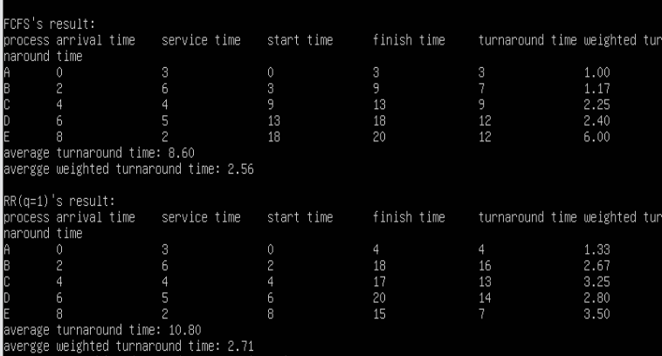
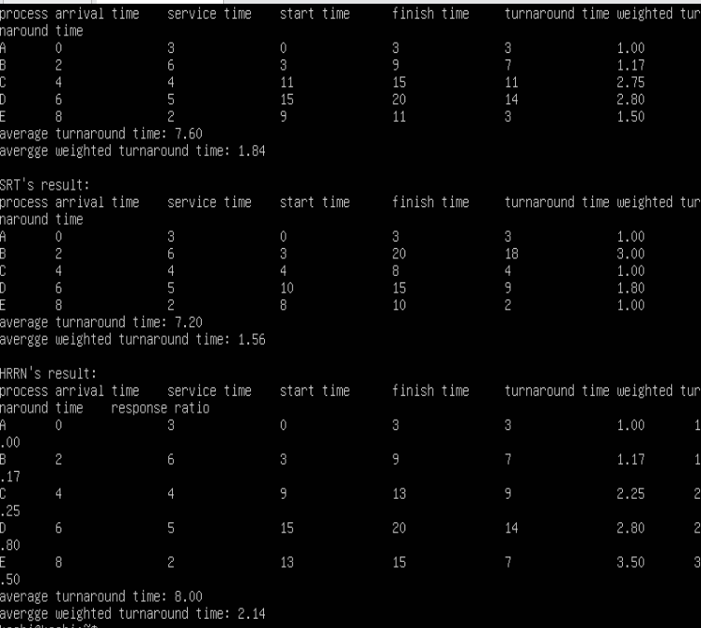

5种调度算法流程如下。completed<n?的是和否有标反，或者认为其为completed>=n?即可。
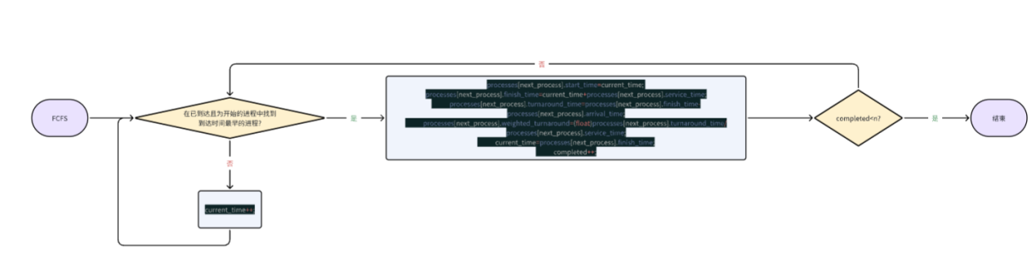
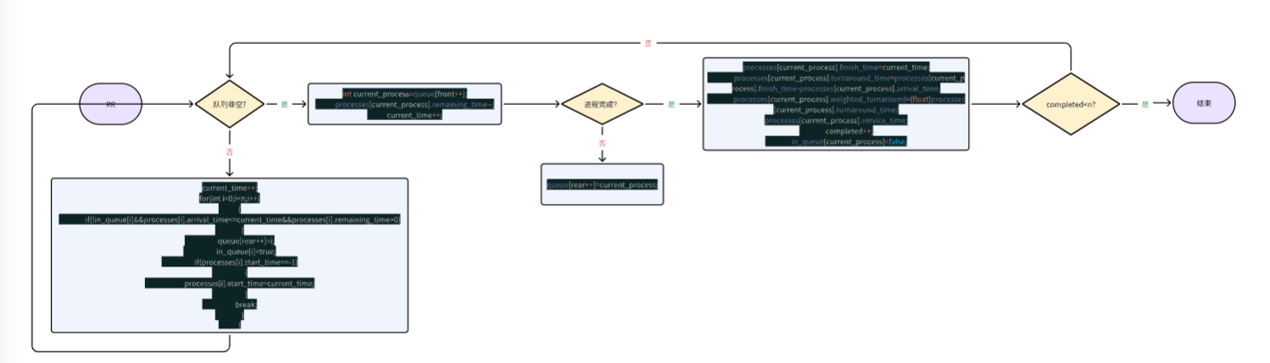
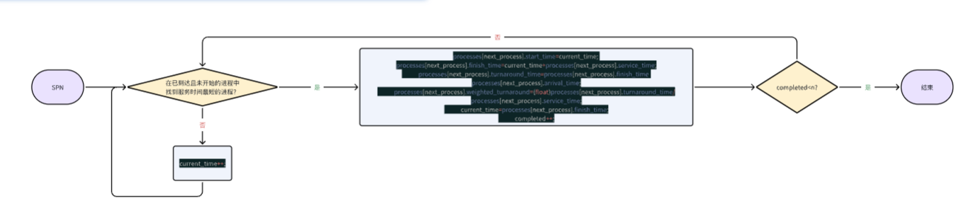
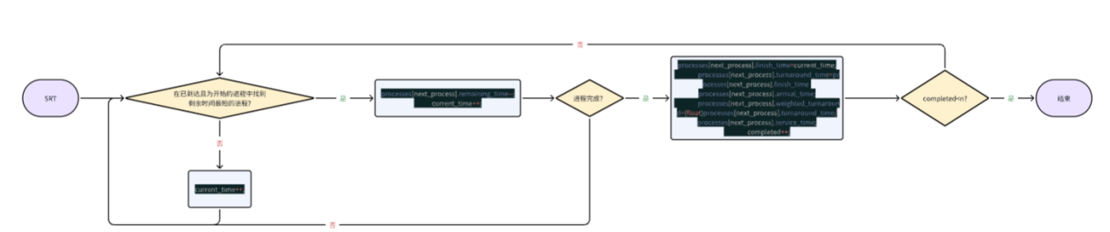
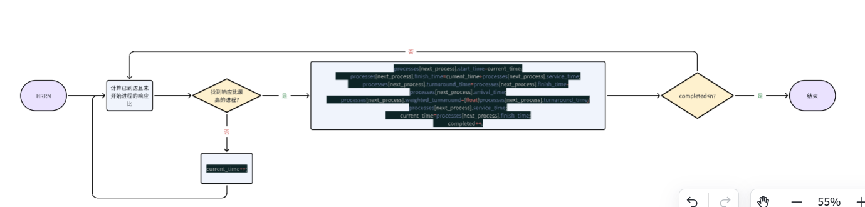

实验总结
本次实验实现了5种算法，通过运行于同一进程调度实例，生动展示了它们之间的区别与优劣，掌握了调度算法的实现过程。

